STEP 1

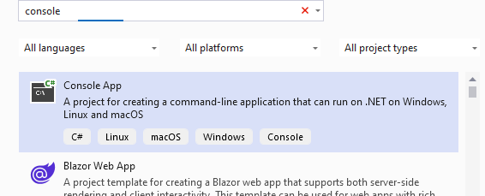

**Step no 1. Use console app for this code ,then select the name ,next, then use .NETapplication which come automatically then next , and inside the console(hello world!) roemove it and put this code there .**

**Aim:** Design ui based application using basic windows forms controls, using classes and objects design applications, using inheritance and abstract classes.

1. design UI based application using basic windows forms controls.
   1. Write a program in c# to print( console base(CUI)):
      1. Factorial of a number
      2. even or odd
      3. prime number or not
      4. reverse of a number

using System;

using System.Collections.Generic; using System.Linq;

using System.Text;

using System.Threading.Tasks;

namespace Practical_1

{

internal class Program

{

static void Main(string[] args)

{

int n, f = 1;

Console.WriteLine("Enter the Number:"); n=Convert.ToInt32(Console.ReadLine()); for (int i = 1; i<n;i++)

{

f = f * i;

}

Console.WriteLine("Factorial " + n + " is a:" + f); Console.ReadKey();

}

}

}

### Output:

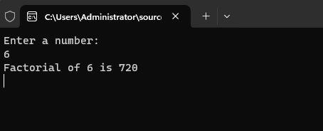

using System;

using System.Collections.Generic; using System.Linq;

using System.Text;

using System.Threading.Tasks;

namespace practical1

{

internal class Program

{

static void Main(string[] args)

{

int n;

Console.WriteLine("Enter a number:"); n=Convert.ToInt32(Console.ReadLine());

if ( n % 2 == 0)

{

Console.WriteLine("it is a even number");

}

else

{

Console.WriteLine("it is a odd number");

}

Console.ReadKey();

}

}

}

### Output:

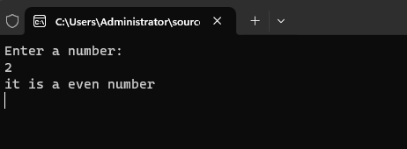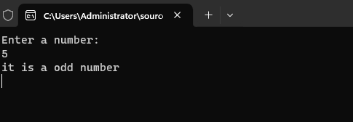

using System;

using System.Collections.Generic; using System.Linq;

using System.Text;

using System.Threading.Tasks;

namespace practical1

{

internal class Program

{

static void Main(string[] args)

{

int n;

int x = 0; int f = 0;

Console.WriteLine("Enter a number:"); n=Convert.ToInt32(Console.ReadLine()); x = n / 2;

for(int i = 2; i <=x; i++)

{

if (n % 1 == 0)

{

Console.WriteLine(n + "is not prime"); f = 1; break;

}

}

if (f == 0)

{

Console.WriteLine(n + " number is prime");

}

Console.ReadKey();

}

}

}

### Output:

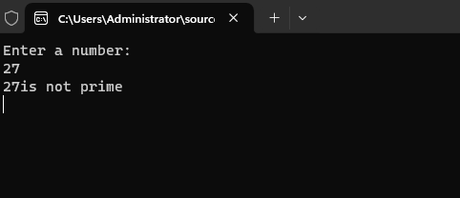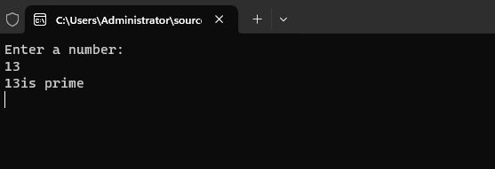

using System; class Program

{

static void Main()

{

int n, r = 0, m;

Console.WriteLine("Mitali Pawar 23MCA35"); Console.WriteLine("Enter a number ");

n = Convert.ToInt32(Console.ReadLine()); while (n != 0)

{

m = n % 10;

r = r * 10 + m; n /= 10;

}

Console.Write("Reversed Number: " + r);

}

}

### Output:

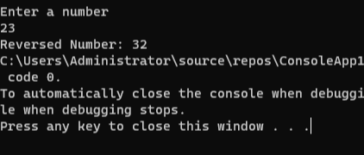

* 1. write a program in c# to make a simple calculator for addition, subtraction, division, multiplication and modulus using GUI in c#.net

### Code:

namespace pract1b

{

public partial class Form1 : Form

{

public Form1()

{

InitializeComponent();

}

private void button5_Click(object sender, EventArgs e)

{

int a = Convert.ToInt32(textBox1.Text); int b = Convert.ToInt32(textBox2.Text); int c = a % b;

label3.Text = c.ToString();

}

private void button1_Click(object sender, EventArgs e)

{

int a = Convert.ToInt32(textBox1.Text);

int b = Convert.ToInt32(textBox2.Text); int c = a + b;

label3.Text = c.ToString();

}

private void button2_Click(object sender, EventArgs e)

{

int a = Convert.ToInt32(textBox1.Text); int b = Convert.ToInt32(textBox2.Text); int c = a - b;

label3.Text = c.ToString();

}

private void button3_Click(object sender, EventArgs e)

{

int a = Convert.ToInt32(textBox1.Text); int b = Convert.ToInt32(textBox2.Text); int c = a * b;

label3.Text = c.ToString();

}

private void button4_Click(object sender, EventArgs e)

{

int a = Convert.ToInt32(textBox1.Text); int b = Convert.ToInt32(textBox2.Text); int c = a / b;

label3.Text = c.ToString();

}

}

}

Output:

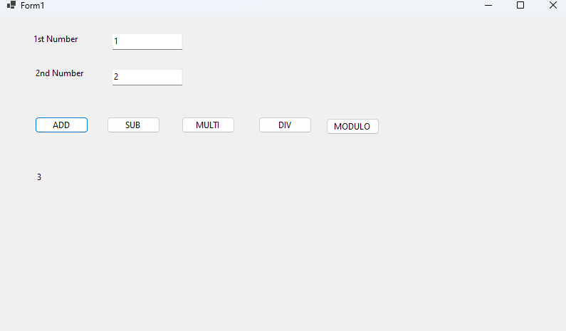

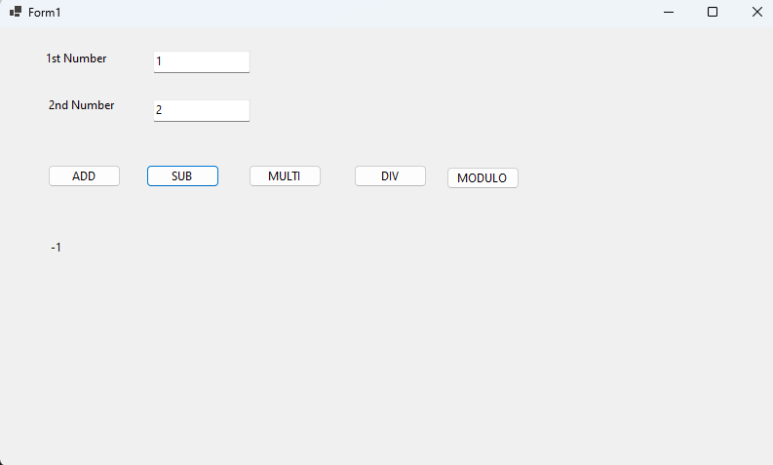

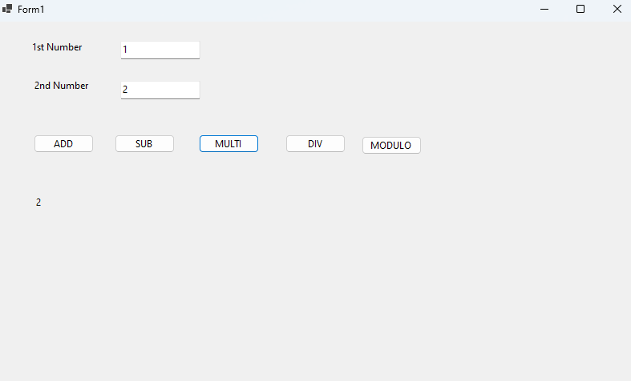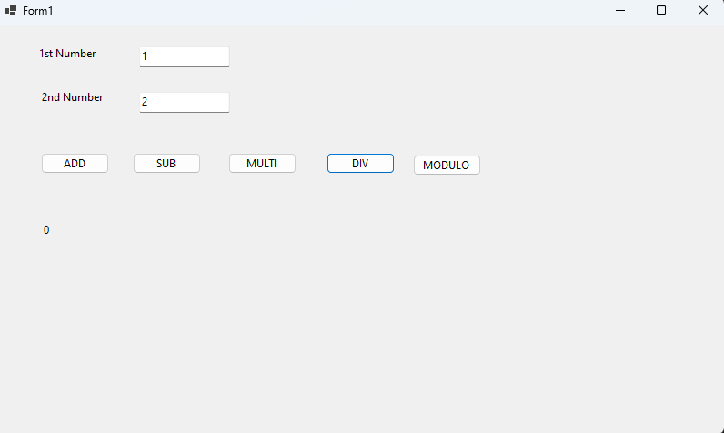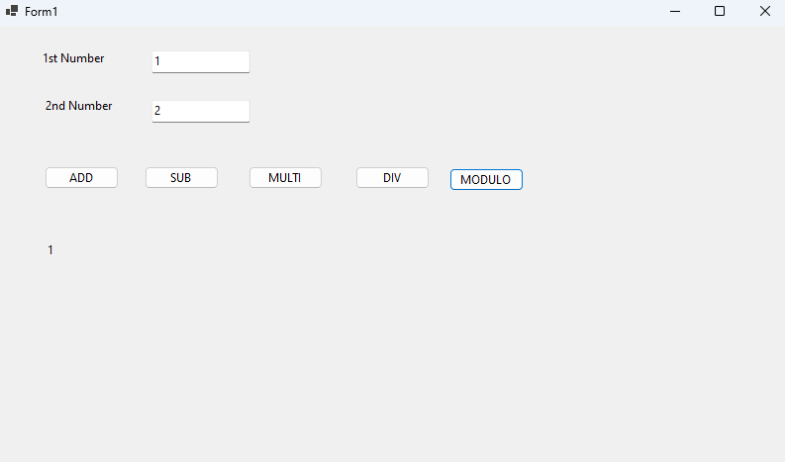

1. Design Application using classes and objects
   1. write a program in c#.net using classes and objects to print addition of two matrix take input from the user

Code:

using System;

using System.Collections.Generic; using System.Data;

using System.Linq; using System.Text;

using System.Threading.Tasks;

class Matrix

{

private int row; private int column; private int[,] data;

public Matrix(int row, int column)

{

this.row = row; this.column = column;

this.data = new int[row, column];

}

public void initialize()

{

Console.WriteLine($"Enter element for a {row}x{column} matrix:"); for (int i = 0; i < row; i++)

{

for (int j = 0; j < column; j++)

{

Console.Write($"Enter element at position ({i + 1},{j + 1}): "); if (int.TryParse(Console.ReadLine(), out int value))

{

data[i, j] = value;

}

else

{

Console.WriteLine("Invalid input. Please enter an integer."); j--;

}

}

}

}

public void Display()

{

Console.WriteLine("Matrix:"); for (int i = 0; i < row; i++)

{

for (int j = 0; j < column; j++)

{

Console.Write($"{data[i, j]} ");

}

Console.WriteLine();

}

}

public static Matrix Add(Matrix matrix1, Matrix matrix2)

{

if (matrix1.row != matrix2.row || matrix1.column != matrix2.column)

{

throw new InvalidOperationException("Matrices must have the same dimensions for addition.");

}

Matrix result = new Matrix(matrix1.row, matrix1.column); for (int i = 0; i < matrix1.row; i++)

{

for (int j = 0; j < matrix1.column; j++)

{

result.data[i, j] = matrix1.data[i, j] + matrix2.data[i, j];

}

}

return result;

}

}

Output:

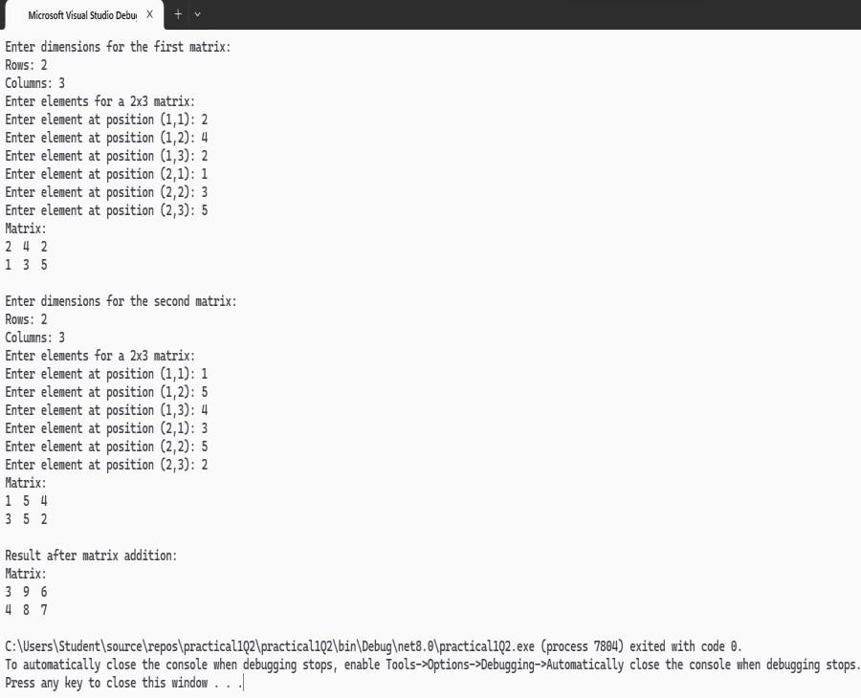

class Program

{

static void Main()

{

Console.WriteLine("Enter dimensions for the first matrix:"); Console.Write("Rows: ");

int rows1 = Convert.ToInt32(Console.ReadLine());

Console.Write("Columns: ");

int columns1 = Convert.ToInt32(Console.ReadLine());

Matrix matrix1 = new Matrix(rows1, columns1); matrix1.initialize();

matrix1.Display();

Console.WriteLine("\nEnter dimensions for the second matrix:"); Console.Write("Rows: ");

int rows2 = Convert.ToInt32(Console.ReadLine());

Console.Write("Columns: ");

int columns2 = Convert.ToInt32(Console.ReadLine());

Matrix matrix2 = new Matrix(rows2, columns2); matrix2.initialize();

matrix2.Display();

try

{

Matrix resultMatrix = Matrix.Add(matrix1, matrix2); Console.WriteLine("\nResult after matrix addition:"); resultMatrix.Display();

}

catch (InvalidOperationException ex)

{

Console.WriteLine($"Error: {ex.Message}");

}

Console.ReadKey();

}

}

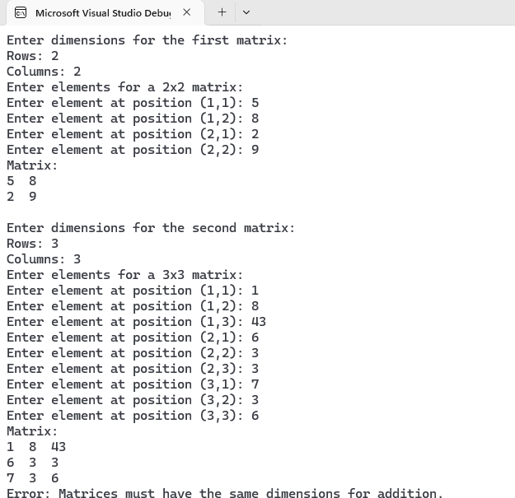

3: Design Application using Inheritance and abstract classes

a.Calculate percentage of Student from marks entered by user using c# .NET using Inheritance and Abstract classes .It should have three classes.

Parent class: student

Derived class: UNdergraduate (derived from student class) Derived Class: PostGraduate(derived from student class)

The postgraduate student has a bonus of 1.2%.using switch case statement perform the above program.

Code:

using System;

using System.Collections.Generic; using System.Linq;

using System.Text;

using System.Threading.Tasks;

abstract class Student

{

protected string name; protected int[] marks;

public Student(string name, int[] marks)

{

this.name = name; this.marks = marks;

}

public abstract double CalculatePercentage();

public void DisplayDetails()

{

Console.WriteLine($"Student Name: {name}"); Console.WriteLine("Marks:");

for (int i = 0; i < marks.Length; i++)

{

Console.WriteLine($"Subject {i + 1}: {marks[i]}");

}

}

}

class Undergraduate : Student

{

public Undergraduate(string name, int[] marks) : base(name, marks)

{

}

public override double CalculatePercentage()

{

int totalMarks = 0;

foreach (int mark in marks)

{

totalMarks += mark;

}

return (double)totalMarks / marks.Length;

}

}

class Postgraduate : Student

{

public Postgraduate(string name, int[] marks) : base(name, marks)

{

}

public override double CalculatePercentage()

{

int totalMarks = 0;

foreach (int mark in marks)

{

totalMarks += mark;

}

return ((double)totalMarks / marks.Length) + 1.2;

}

}

class Program

{

static void Main()

{

Console.Write("Enter student name: "); string name = Console.ReadLine();

Console.Write("Enter the number of subjects: ");

int numSubjects = Convert.ToInt32(Console.ReadLine());

int[] marks = new int[numSubjects]; for (int i = 0; i < numSubjects; i++)

{

Console.Write($"Enter marks for Subject {i + 1}: "); marks[i] = Convert.ToInt32(Console.ReadLine());

}

Console.WriteLine("\nSelect student type:"); Console.WriteLine("1. Undergraduate"); Console.WriteLine("2. Postgraduate");

int choice = Convert.ToInt32(Console.ReadLine()); Student student;

switch (choice)

{

case 1:

student = new Undergraduate(name, marks); break;

case 2:

student = new Postgraduate(name, marks); break;

default:

Console.WriteLine("Invalid choice. Defaulting to Undergraduate."); student = new Undergraduate(name, marks);

break;

}

Console.WriteLine("\nStudent Details:"); student.DisplayDetails();

double percentage = student.CalculatePercentage(); Console.WriteLine($"\nPercentage: {percentage}%");

Console.ReadKey();

}

}

Output:

